**PRODUCT BACKLOG REFINEMENT-SPRINT 3**



**Date:12/3/2017**

Contents

I. BACKLOG ESTIMATE EVIDENCES 3

1. Log in with facebook 3

2. View other user profile 3

3. Request log 4

4. Auto match(User recommended swap) 4

5. FEEDBACK 4

6. EDIT PASSWORD 5

# BACKLOG ESTIMATE EVIDENCES

## Log in with facebook

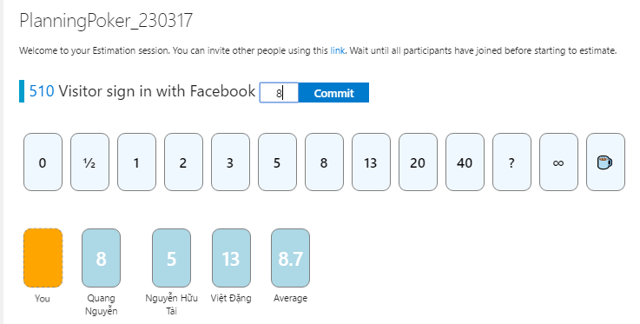

## View other user profile

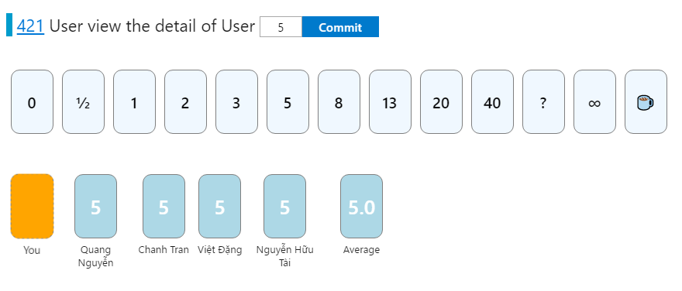

## Request log

C:\Users\Windows 10 TIMT\Desktop\Sprintbacklogrefinement1-2\Viewrequestlog.PNG

## Auto match(User recommended swap)

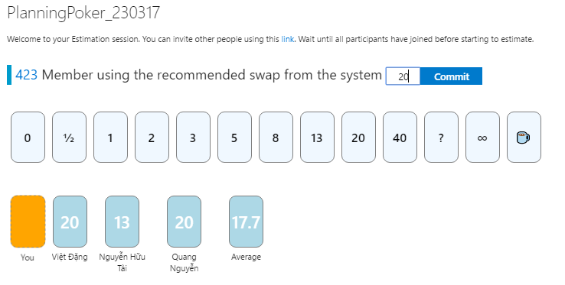

## FEEDBACK

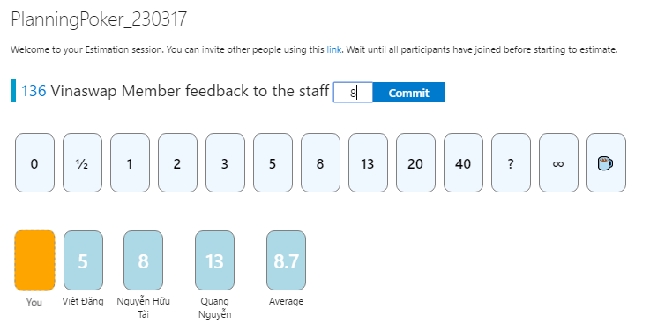

## EDIT PASSWORD

